EXP3: Water Jug Problem
Name: Y. Roshitha (192424400)

Aim:
To develop a Python program that solves the Water Jug Problem using the Breadth-First Search (BFS) algorithm, determining the sequence of fill, empty, and pour operations required to measure the target quantity of water.

Algorithm:
Step 1: Start with both jugs empty, state (0, 0).
Step 2: Check if the current state contains the target quantity in either jug.
Step 3: Generate all possible next states from the current state:
- Fill Jug 1 completely.
- Fill Jug 2 completely.
- Empty Jug 1 completely.
- Empty Jug 2 completely.
- Pour water from Jug 1 into Jug 2 until Jug 1 is empty or Jug 2 is full.
- Pour water from Jug 2 into Jug 1 until Jug 2 is empty or Jug 1 is full.
Step 4: Add all unvisited states to the BFS queue.
Step 5: Mark the current state as visited.
Step 6: Repeat Steps 2-5 until the target quantity is reached.
Step 7: Return the complete path from the initial state to the goal state.

Source Code:
from collections import deque

def water_jug_bfs(cap1, cap2, target):
start = (0, 0)
visited = set([start])
queue = deque([(start, [start])])

while queue:
(a, b), path = queue.popleft()

if a == target or b == target:
return path

next_states = [
(cap1, b), # Fill jug1
(a, cap2), # Fill jug2
(0, b), # Empty jug1
(a, 0), # Empty jug2
(a - min(a, cap2 - b), b + min(a, cap2 - b)), # Pour jug1 -> jug2
(a + min(b, cap1 - a), b - min(b, cap1 - a)), # Pour jug2 -> jug1
]

for state in next_states:
if state not in visited:
visited.add(state)
queue.append((state, path + [state]))

return None

CAP1, CAP2, TARGET = 4, 3, 2

solution = water_jug_bfs(CAP1, CAP2, TARGET)

print("Steps to solve the Water Jug Problem:\n")
if solution:
step = 1
for state in solution:
print(f"Step {step}: Jug1 = {state[0]}, Jug2 = {state[1]}")
step += 1
else:
print("No solution found.")

Flowchart:

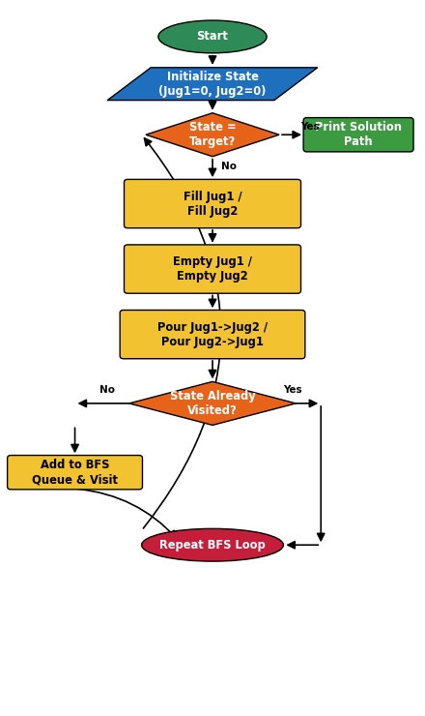

Output:

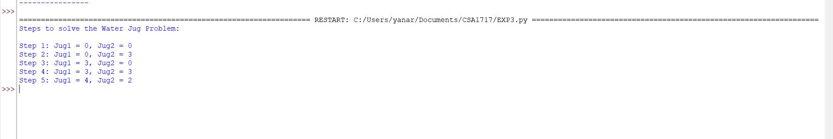

Result:
The Water Jug program successfully found a sequence of fill, empty, and pour operations that measured the required target quantity of water using two jugs of capacities 4 litres and 3 litres. The Breadth-First Search algorithm explored all reachable states level-by-level and returned the shortest sequence of operations.
During execution, the program displayed each intermediate state clearly, showing the water level in both jugs after every operation, until the target quantity of 2 litres was obtained in Jug 1.
Thus, the Water Jug Problem was solved successfully using the Breadth-First Search (BFS) algorithm.

